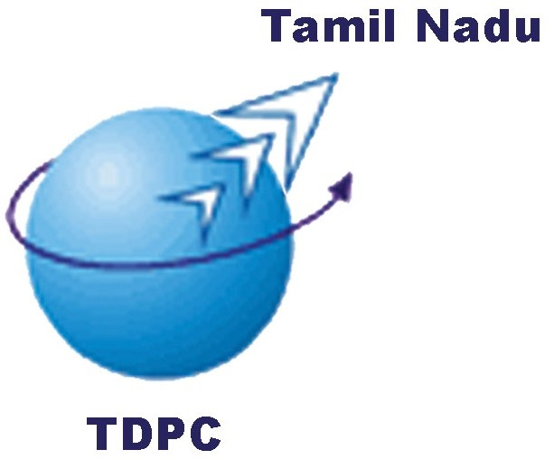


MSME Tech Summit
Theme: Building Global Competitiveness through Technology and Innovation
22nd August 2018: 0900 Hrs: Hotel ITC Grand Chola, Chennai

Conference Delegate Registration Form
Please tick (✓)

[ ] I will attend this conference.

[ ] We nominate the following from our organisation to attend this conference.

Name Designation E-mail Mobile

1. ________________ _______________ _____________ ____________
2. ________________ _______________ _____________ ____________
3. ________________ _______________ _____________ ____________
4. ________________ _______________ _____________ ____________
5. ________________ _______________ _____________ ____________
Delegate Fee
(Per Participant/including Service tax)
Category | Rs. (INR)
CII Member | 3000
Non Member | 4000
Academic Institution | 2500
Overseas Participant | 5000

Note:  Delegate fee is non-refundable.  Change in nomination is accepted
 For every Four registrations, one will be complementary * Prior registration is essential
* We would accept the nominations on first-come-first served basis.

Our Cheque/DD No.__________ for Rs. ________ dated ________ Bank: ________ drawn in favour of Tamil Nadu Technology Development and Promotion Center payable at Chennai is enclosed.

Membership No. _________ (only CII Member)
Nominated by: Name: __________________________ Desig.: ______________
Company: _______________________________________________________
Address: _______________________________________________________
Phone: _________________________ Fax: _______________________________

Email: ______________________________Mobile: _________________________

You are requested to send your reply by email, post or fax to:

Regin Jude Cline A
Tamil Nadu Technology Development and Promotion Center
Confederation of Indian Industry
98/1, Velachery Main Road, Chennai 600 032, India Tel: +91-44- 42444555/ 628 (D)
Mob. 7598846561 Fax: +91-44- 42444510 Email: regin.a@cii.in

